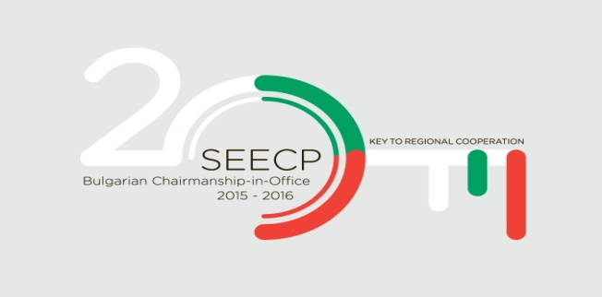

SEECP JOINT STATEMENT ON MIGRATION CHALLENGES

Sofia, 2 February 2016

We, the Ministers of Foreign Affairs of the South East European Cooperation Process (SEECP) Participants met in Sofia on 2 February 2016, in the presence of the Secretary General of the Regional Cooperation Council and of the representatives of the European Union,

Committed to the principles of good-neighbourly relations, territorial integrity and regional ownership, as the ground for the successful implementation of the regional cooperation in Southeast Europe (SEE),

Rеiterating the importance of SEECP as the main political format for regional cooperation and a factor for security, stability and prosperity in SEE,

Determined to safeguard the essential values of democracy, rule of law and respect for human rights and fundamental freedoms as the basis of economic and social progress,

Considering that the unprecedented mixed migration flows the region is facing have become a major economic, social, humanitarian, political and security concern for the SEECP Participants,
Emphasizing that the best and effective way of dealing with irregular migration is to build meaningful cooperation between the SEECP Participants,

Recalling the resolutions and declarations on migration in the framework of the UN, OSCE, Council of Europe, EU and оther relevant organizations and institutions, as well as the SEECP Joint Statement on Terrorism, adopted in Tirana, 24 February 2015,

Have agreed on the following:
      - Express our high interest to alleviate the serious effects that the continuous migratory pressure poses to the border management and security, and to the justice, social, economic and asylum systems;

- Recognize the need to act in a spirit of responsibility and solidarity to ensure concerted action, effective coordination and evenhanded management of migration flows in SEE;
- Confirm our determination, with respect for human rights and the rule of law, to maintain a zero tolerance approach to all acts aimed at challenging our common values, security and the established public order;

- Reiterate that only a comprehensive cross-border approach seeking to find long-term solution can be successful, and being aware that coordinated actions may facilitate positive and concrete effects, stress the need for continuous enhanced cooperation at international, European, regional, national and local levels;

      - Express our readiness to enhance coordination regarding the movement of migratory flows through relevant information exchange within our region, as well as with relevant EU agencies, international organizations and third countries. In this regard, point out the need on early notification on new measures to be introduced;

      - Reaffirm our determination to prevent illegal border crossing and risky journeys, and to fight against organized crime, migrant smuggling and trafficking in human beings, including through an enhanced border management;

      - Emphasize the need of improving the dialogue with the countries of origin of irregular migrants. All tools shall be mobilized to enable effective return, in full respect of the principle of non-refoulement, and readmission procedures as one of the main topics of our cooperation with those countries;

      - Share the understanding that the focus of the international efforts should be kept on addressing the root causes of migration;

      - Recognize that finding political solutions to the existing conflicts generating migration flows towards our region, as well as the defeat of ISIL/Da’esh, are indispensable prerequisites for successful management and mitigation of the migration in SEE;

- Reaffirm our commitment to intensify cooperation in the fight against terrorism and to address the phenomenon of foreign terrorist fighters through the Western Balkan Counter-Terrorism Initiative (WBCTi) and the RCC led Regional Platform for Countering Radicalisation and Violent Extremism;

- Welcome the provision of financial assistance from the EU Regional Trust Fund in Response to the Syrian Crisis, the Madad Fund, as well as the proposal to extend it to the Western Balkans, in order to improve our common response to the migration challenges;

- Pledge full support for the activities of the international community aiming at effectively addressing the challenges of the migration crisis.

